CS 6840
Formal System Design
Spring Semester 2026

NDFS-Check: A Tool for Checking Buchi Automata Emptiness
Due: 4/21/2026
Jacob Brown

Problem Statement: This project implements NDFS-Check, a command-line tool that reads a finite-state transition system from a simple text file, builds the product with a Buchi Automaton generated from an LTL formula, and applies the Nested Depth First Search algorithm to decide emptiness. It reports whether an accepting cycle exists, demonstrating a core component of formal verification.
Code Modules: The following code modules have been created to accomplish this.
- ast_nodes.py: This module contains the Abstract Syntax Tree (AST) definitions for propositional and LTL formulas
- buchi_builder.py: This module builds the Buchi Automata for a limited number of LTL Formula using the NNF.
- ltl_negation.py: This module transforms each LTL formula into its negation in Negation Normal Form (NNF).
- ltl_parser.py: This module parses the LTL formulas and stores them in a Formula data structure.
- model_parser.py: This module parses the model and stores it in a Transition System data structure.
- ndfs.py: This module contains the Nested Depth-First Search (NDFS) algorithm that first explores the whole reachable part of the product, and then triggers the inner DFS when an accepting state is found.
- printer.py: This module prints the results of the NDFS. This includes both original and negated LTL, number of Buchi and Product States, emptiness of the product, and the prefix and accepting cycle if emptiness is not satisfied.
- product_builder.py: This module builds the product using the TS and Buchi Automata.
- structures.py: This module contains structures for TS, BA, Product Automaton, and NDFSResult.
- NDFS_Check.py: This is the main module that calls all the utility functions.
Example Transition System: The following is an example of a Traffic Light Transition System, and the simple text file to be read by the code.
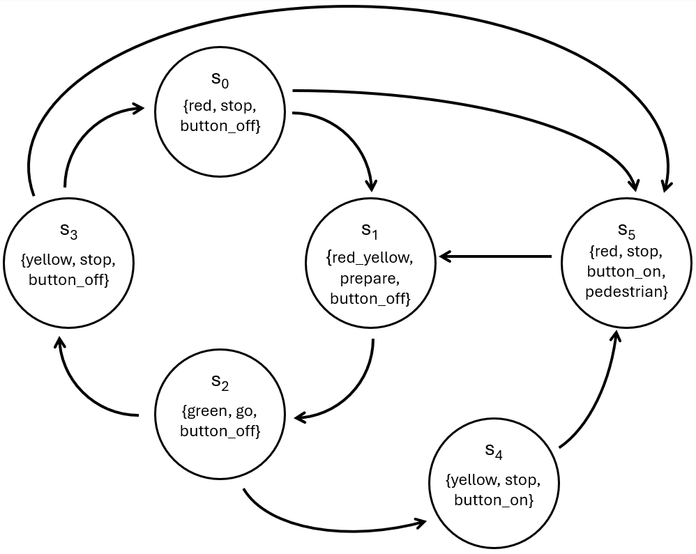
Figure 1: Simple Traffic Light with Pedestrian Crossing Kripke Transition System
Traffic_Light_Graph.txt: This file contains the textual representation of the Kripke Model above.
# Adjacency List (space-separated)
s0 s1 s5
s1 s2
s2 s3 s4
s3 s0 s5
s4 s5
s5 s1

# Initial State
init: s0

# Proposition Labelling (space-separated list after colon)
s0: red stop button_off
s1: red_yellow prepare button_off
s2: green go button_off
s3: yellow stop button_off
s4: yellow stop button_on
s5 red stop button_on pedestrian
Traffic_LTL.txt: This file contains the LTL formulas that will be converted into Buchi Automata from which the product is built with the transition system to check for emptiness using NDFS. This file is also textual so regular LTL symbols are not used, instead we use the following:
- G – Globally, or always
- F – Eventually
- X – Next
- ! – Negate
- || – Or
- && – And
- -> – Implies
- U – Until
- R – Release
Here are a few examples:
G button_off
F pedestrian
G (button_on -> F pedestrian)
G (!(green && pedestrian))
G (red -> X (red || red_yellow))
(!pedestrian) U (red && button_on)
Example Run:
python NDFS_Check.py “Traffic_Light_Graph.txt” “Traffic_LTL.txt”

